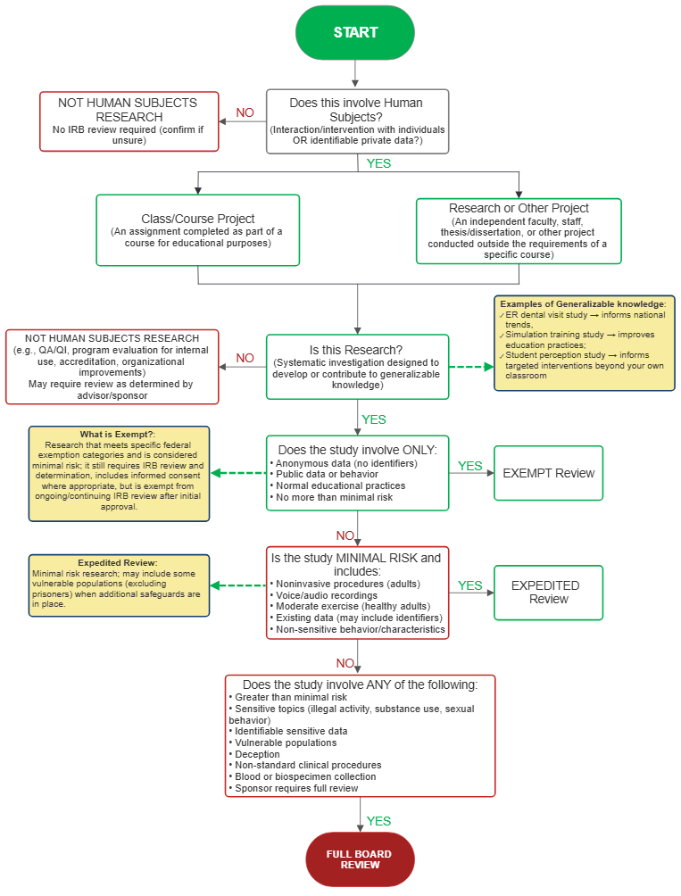

IRB Determination Checklist
Step 1: Not Human Subjects Research (Start Here)*
☐ The project involves no interaction or intervention with living individuals.
☐ The project does not collect, receive, access, or use identifiable private information or identifiable biospecimens.
☐ The project uses existing data that are fully de-identified, with no code, key, or other means available to the research team to readily identify individuals.
☐ The activity is conducted solely for internal quality improvement, program evaluation, operational improvement, or accreditation purposes and is not designed to develop or contribute to generalizable knowledge.
☐ The activity is limited to a literature review, systematic review, or meta-analysis of previously published information and does not involve obtaining identifiable private information about living individuals.
☐ The activity involves only publicly available information and does not involve interaction or intervention with individuals or access to identifiable private information.
If one or more of the categories above describes your project, it may qualify as Not Human Subjects Research (NHSR). Do not assume that IRB review is unnecessary based solely on this checklist. If you are uncertain whether your project constitutes human subjects research, submit the appropriate NHSR/Determination Request to the SVSU IRB for an official determination.
NOTE: Submit for administrative review.
*Student projects may require additional review as determined by advisor/sponsor. Examples of Generalizable knowledge: ER dental visit study → informs national trends, Simulation training study → improves education practices; Student perception study → informs targeted interventions beyond your own classroom.

If none of these categories applies, continue to Step 2.
Step 2: Exempt Review (Lowest Risk)**
☐ Anonymous surveys/interviews
☐ No identifiers collected or linked
☐ Public behavior observation
☐ Publicly available data
☐ De-identified existing data
☐ Normal educational practices in standard settings
If applicable and no higher-risk elements → Exempt Review
NOTE: Submit for Review by the IRB Chair
**What is Exempt? Research that meets specific federal exemption categories and is considered minimal risk; it still requires IRB review and determination, includes informed consent where appropriate, but is exempt from ongoing/continuing IRB review after initial approval.
Step 3: Expedited Review (Minimal Risk)***
☐ Minimal risk only (daily life level)
☐ Noninvasive procedures (adults)
☐ Audio/voice recordings
☐ Moderate exercise (healthy adults)
☐ Existing data, records, or specimens (may be identifiable)
☐ Behavioral research without stress/manipulation
If ANY checked and no Full Board triggers → Expedited Review
***Expedited Review: Minimal risk research; may include some vulnerable populations (excluding prisoners) when additional safeguards are in place.
Step 4: Full Board Review (Highest Risk)
☐ Greater than minimal risk
☐ Psychological stress, discomfort, or harm possible
☐ Sensitive topics (illegal activity, drug/alcohol use, sexual behavior)
☐ Identifiable sensitive data
☐ Risk to employability, reputation, or legal standing
☐ Vulnerable populations (children, prisoners, pregnant individuals, impaired)
☐ Deception or incomplete informed consent
☐ Non-standard clinical procedures/interventions
☐ Collection of blood or biological specimens not part of routine clinical care
☐ External sponsor requires full IRB review

If ANY checked → Full Board Review
Quick Logic
- Not human subjects? → Will receive administrative review
- Anonymous/no identifiers? → Exempt – Will received review by IRB Chair
- Minimal risk? → Expedited – Will received review by IRB Chair or an IRB Committee member
- Anything higher risk or sensitive? → Full Board – Will be reviewed by entire IRB Committee

